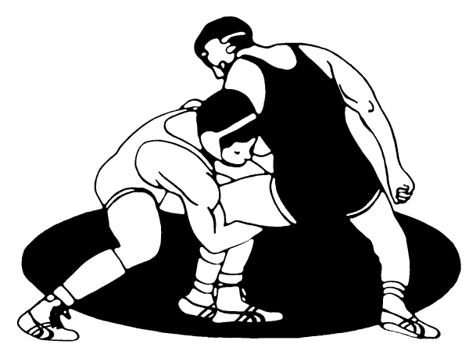
Charger Wrestling Club

Charger Wrestling Club will focus on teaching the basic skills and fundamentals necessary to compete in the great sport of wrestling. Competing in wrestling can promote a higher level of self-confidence, discipline, concentration, and coordination.
Grades PreK-8th – All skill levels welcome!
When: Practices will be Tues., Wed., and Thurs. in the CCHS wrestling room.
preK-2nd = 5:15-6:00 p.m. 3rd-5th = 6:00-7:15 p.m. 6th-8th = 7:15-8:45 p.m.

Cost: preK-2nd = $105 3rd-8th = $155
Included in the cost is a Charger Wrestling t-shirt!

All participants must purchase a limited Folkstyle ($15) USA Wrestling Membership. Details for purchase can be found on the registration page.
https://www.usawmembership.com/login

Online Registration Only
Grades Prek-2: https://canyons.revtrak.net/wrestling-camps-grades-prek-2#/list
Grades 3-8: https://canyons.revtrak.net/wrestling-camps-grades-3-8#/list
(Detailed calendar with all practices and tournaments will be distributed at the first practice.)
First Practice: October 30, 2018

If you have any questions please contact Jeff Eure: jeffrey.eure@canyonsdistrict.org 801-826-6468

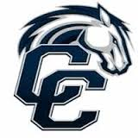
“Building Tradition”

www.chargerwrestling.weebly.com
Charger Wrestling Club

Charger Wrestling Club will focus on teaching the basic skills and fundamentals necessary to compete in the great sport of wrestling. Competing in wrestling can promote a higher level of self-confidence, discipline, concentration, and coordination.
Grades PreK-8th – All skill levels welcome!
When: Practices will be Tues., Wed., and Thurs. in the CCHS wrestling room.
preK-2nd = 5:15-6:00 p.m. 3rd-5th = 6:00-7:15 p.m. 6th-8th = 7:15-8:45 p.m.

Cost: preK-2nd = $105 3rd-8th = $155
Included in the cost is a Charger Wrestling t-shirt!

All participants must purchase a limited Folkstyle ($15) USA Wrestling Membership. Details for purchase can be found on the registration page.
https://www.usawmembership.com/login

Online Registration Only
Grades Prek-2: https://canyons.revtrak.net/wrestling-camps-grades-prek-2#/list
Grades 3-8: https://canyons.revtrak.net/wrestling-camps-grades-3-8#/list
(Detailed calendar with all practices and tournaments will be distributed at the first practice.)
First Practice: October 30, 2018

If you have any questions please contact Jeff Eure: jeffrey.eure@canyonsdistrict.org 801-826-6468

“Building Tradition”

www.chargerwrestling.weebly.com

